SLA management For Hardware Group Priority 4

1. **Project Overview**

To ensure consistent service delivery and meet agreed-upon expectations for the priority 4 project in the hardware group.SLA(service level agreement)management establishes the framework for accountability , timelines,and performance standards.

# Objectives

To implement and manage a service level Agreement (SLA)in serviceNow for hardware-related incident That are categorized as priority 4.The primary goal is to ensure timely response and resolution of hardware incidents within a defined 16 hours business time frame, enhancing customer satisfaction and operational efficiency.

# Key Features and Concepts Utilized

## Service level Agreement (SLAs) with conditional management

The SLA for priority 4 hardware incidents is configured in serviceNow to intiate tracking once an incident is created and assigned the appropriate priority and category.

Pause condition :The SLA timer automatically pauses when the incident status is changed to on Hold. This allows time tracking to be more accurate, preventing SLA breaches when delays are outside the team’s control(e.g ,awaiting vendor response).

Stop condition :The SLA ends when the incident status changes to resolved or closed, ensuring the SLA accurately reflects the active resolution time.

## Business Hours and schedule Management

The SLA is set to follow business hours ,meaning the 16-hour SLA only counts time during scheduled working hours, preventing after-hours time form affecting the SLA.

Schedule Setup: ServiceNow’s scheduling features defines and applies the organization’s business hours,including considerations for holidays and weekends. The ensures that the SLA respects

standard working schedules and aligns with the orgainization’s availability,enchancing the accuracy of SLA tracking.

## Notifications and Escalations

To proactively manage SLA adherence, notifications and escalations are configurd.This include automated alerts to the Hardware support Group and relevant stakeholders when an incident is nearing its SLA breach thereshold.

Escalation Paths: Escalation rules are set so that incidents approaching SLA limits trigger alerts to supervisors or managers, enabling them to reassign resources or prioritize as needed.

Real-time Monitoring and Reporting: Dashboards and reports provide visibility into SLA performance, allowing the team to monitor SLA compliance in real time and analyze trends to support continuous improvement.

These features collectively enhance SLA management by aligning incident handling with both organizational needs and customer expectations for timely service, while allowing the team flexibility when external dependencies affect incident resolution.

# Detailed Steps to Solution Design

**Implementation**

**Activity-1**

1. Open service now developer Instance
2. Click on All
3. Search for SLA Definition

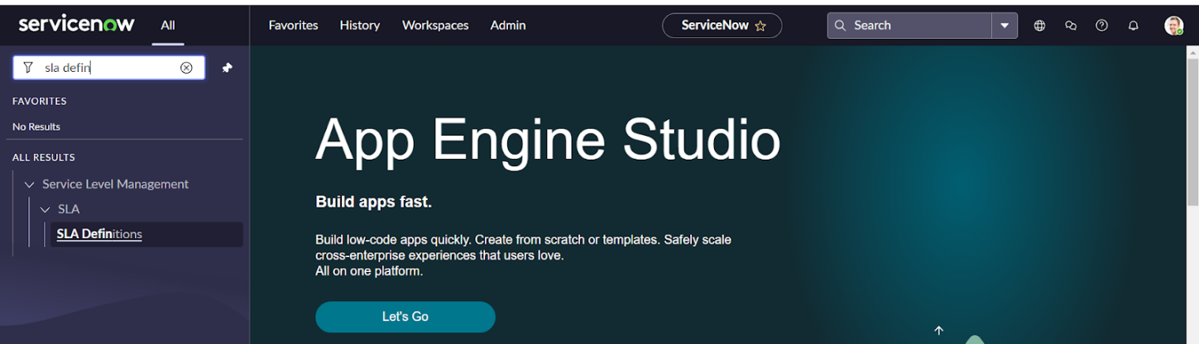

4 .Create New

5.Fill the information as mentioned below  
Name : Hardware Group - Priority 4  
Type : SLA  
Target : Response  
Table : incident  
Duration : 1 hour

Schedule source : No schedule  
 Leave the other things default

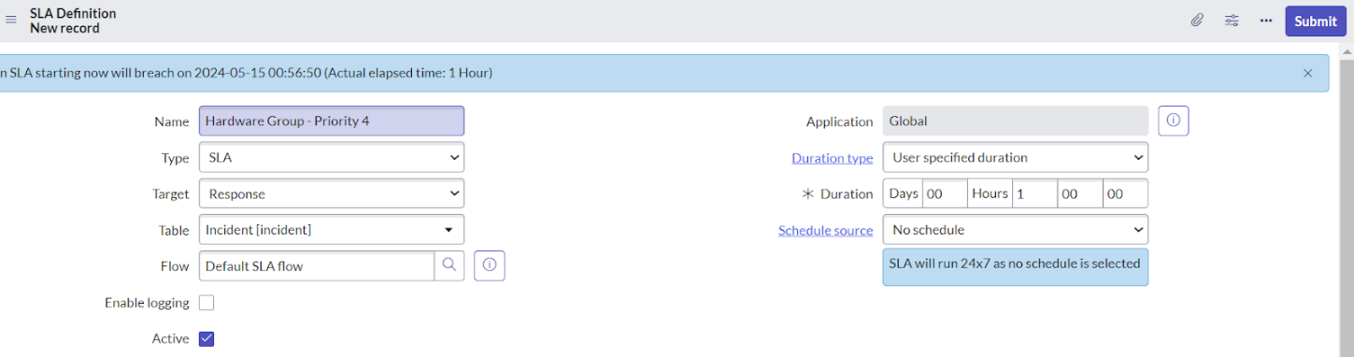

1. Under start condition fill the given information  
   Active>>is>>true  
   Priority>>is>>4-low

State>>is>>New

1. Under when to cancel choose

When start condition is not met.

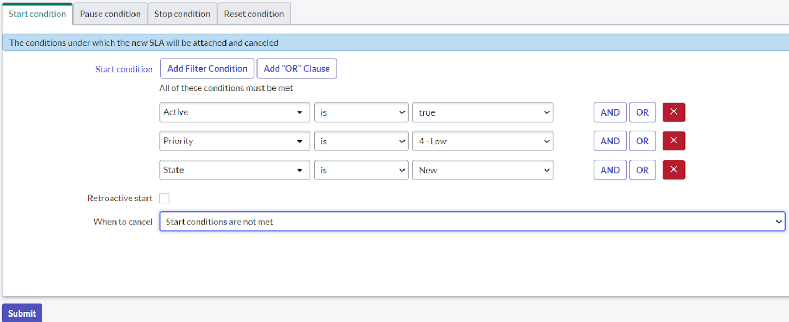

1. Under stop condition  
   Assignment group >> is not empty

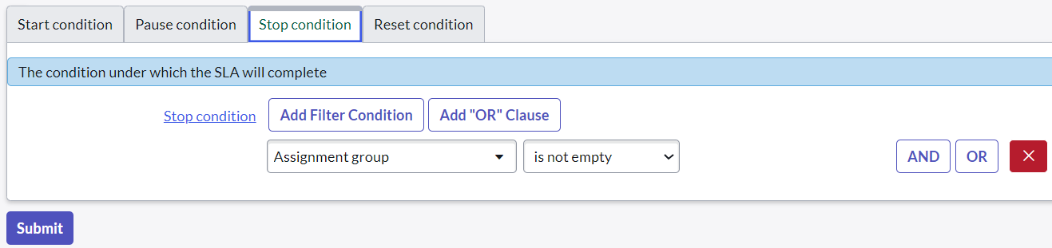

1. Click on submit.

**Activity - 2:**

1. Click on All
2. Search for SLA Definition  
   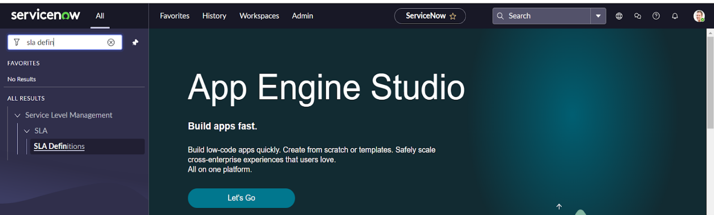
3. Create New
4. Fill the information as mentioned below

Name : Hardware Group-Resolution  
Type : SLA  
Target : Resolution  
Table : incident  
Duration : 16 hour

Schedule source : No schedule  
Leave the other things default

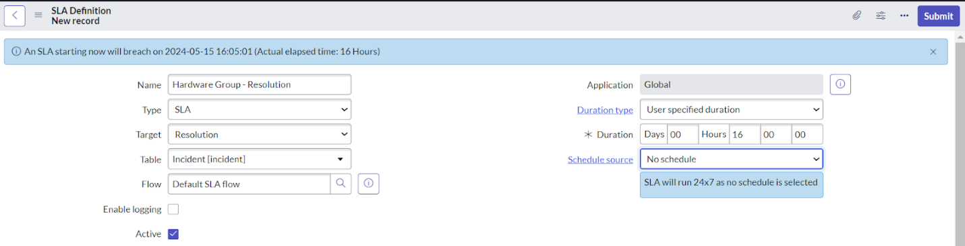

1. Under start condition fill the given information

Assignment group >> is not empty

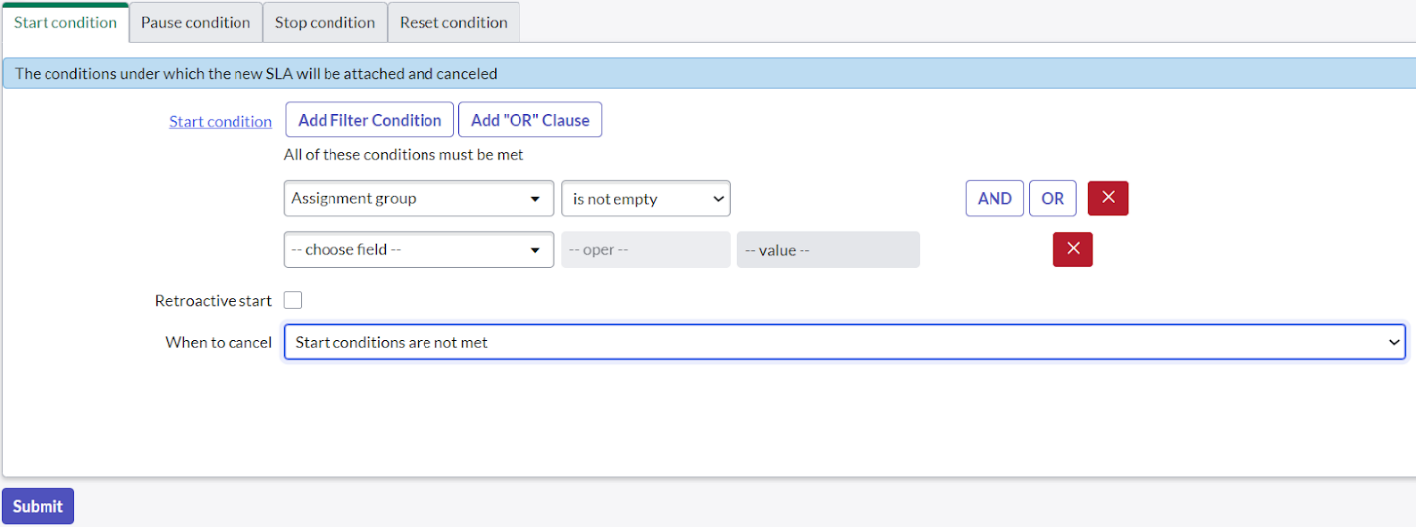

1. Under pause condition fill the following information  
   state>>is>>onhold
2. Under when to resume choose  
   When pause conditions are not met

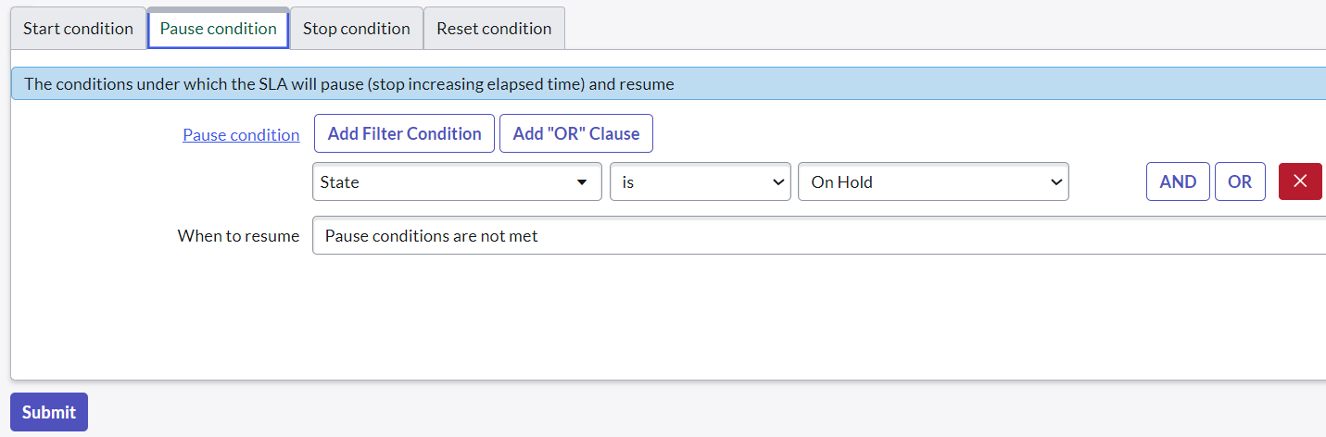

1. Under stop condition fill the following information  
   State>>is one of>>resolved,closed  
   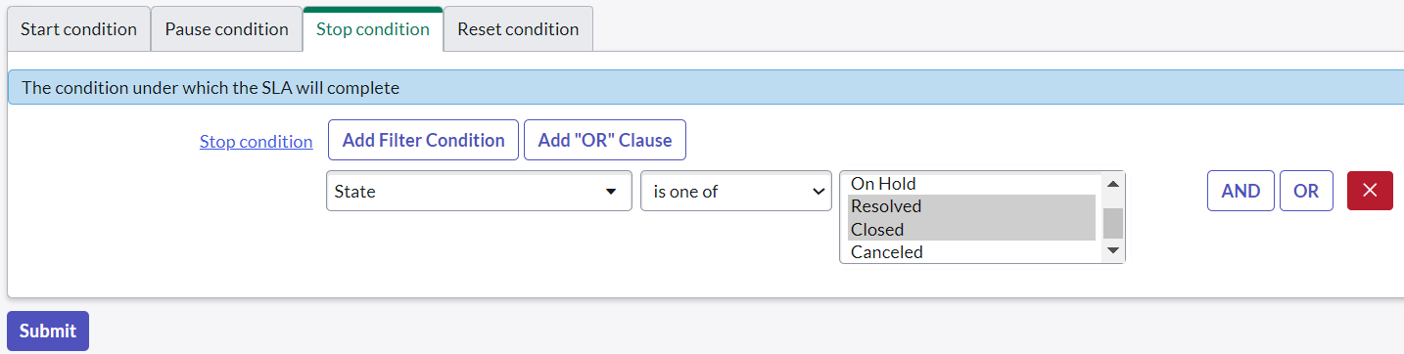
2. Click on submit.

**Result**

1. **Navigate to ALL**
2. **Search for incident**
3. **Click on create new**
4. **Fill the incident form and click on save**

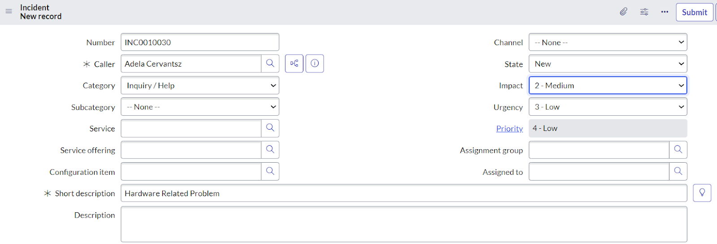

1. **Scroll down under SLA you will find SLA response.**

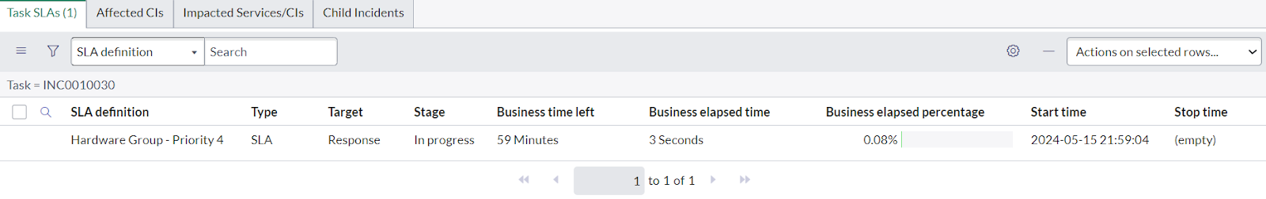

1. **Now under assignment group give hardware and click on save.**

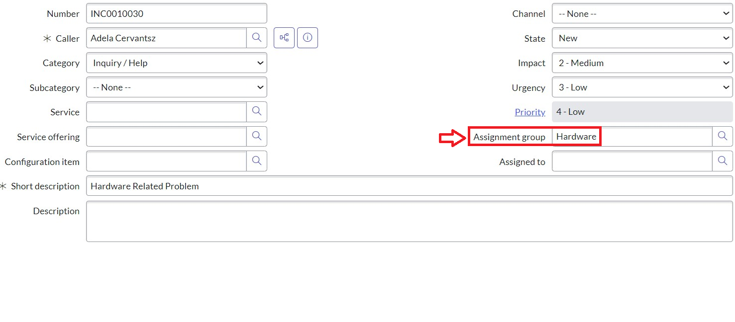

1. **Under sla you will find SLA response should completed and SLA resolution will start.**

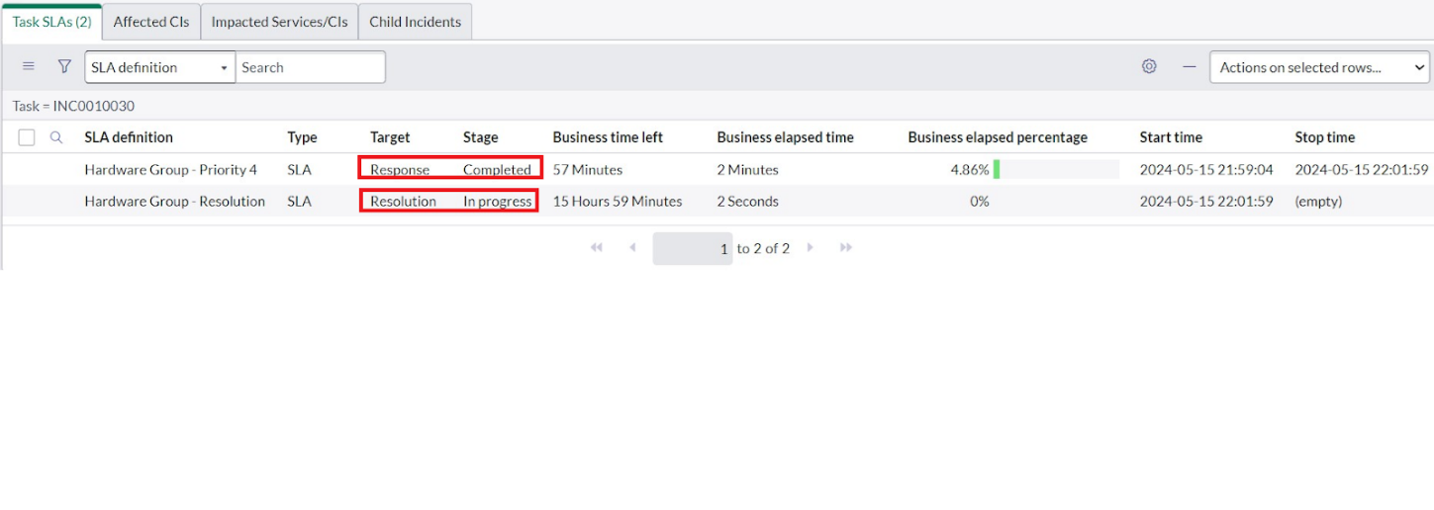

1. **If we change state to resolve you will observe resolution to completed.**

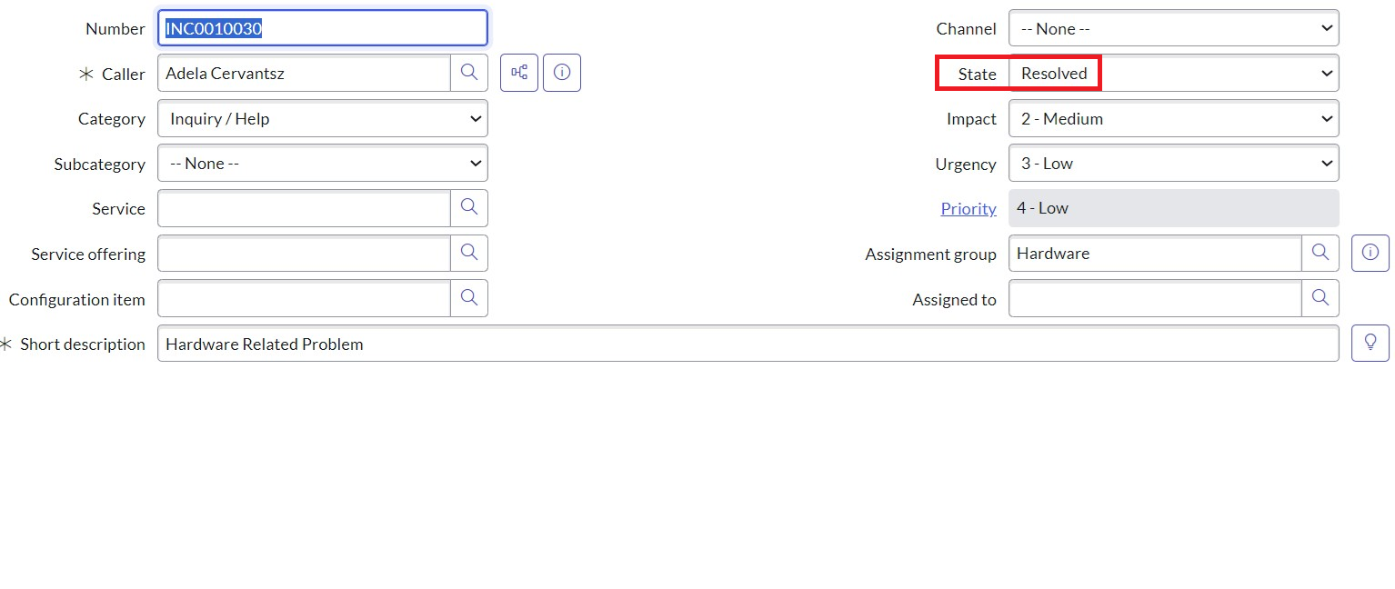

1. **You will observe resolution state is in completed**

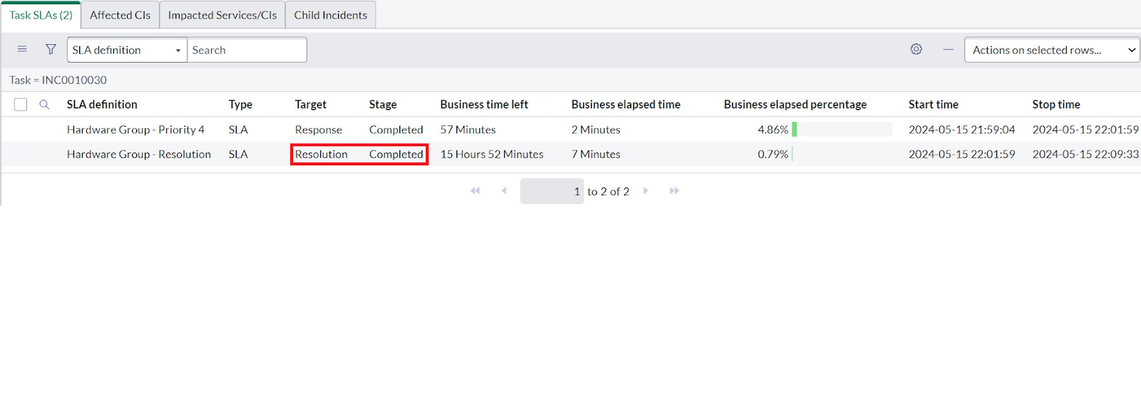

# Testing and Validation

**a. SLA Definition Testing**

* Ensure that SLA parameters for Priority 4 are clearly defined and align with business needs.
* Test system configurations to verify that Priority 4 SLAs are correctly implemented in the incident management tool.
* Validate escalation policies if SLA thresholds are breached.

**b. Incident Creation and Categorization Testing**

* Verify that incidents logged with P4 priority are categorized correctly.
* Simulate various P4 scenarios (e.g., non-urgent hardware issues) to ensure proper tagging and prioritization.

**c. Notification and Escalation Testing**

* Test that stakeholders receive notifications for P4 incidents according to SLA-defined timelines.
* Validate that escalation rules (if SLAs are exceeded) function as expected.

**d. Workflows and Ticketing System Validation**

* Simulate the end-to-end workflow for a P4 incident:
  1. Creation and logging.
  2. Assignment to the hardware group.
  3. Acknowledgment by the assignee within the SLA-defined response time.
  4. Resolution within the required time frame.
* Confirm that the ticketing system supports documentation and time-stamping of all actions.

**e. Hardware Issue Resolution Testing**

* Conduct tests for typical P4 hardware resolutions:
  + Physical hardware checks.
  + Minor fixes like replacing non-critical parts.
  + Validating redundant system configurations to ensure no downtime.

**f. Reporting and Metrics Validation**

* Ensure reports generated for P4 incidents accurately reflect SLA compliance.
* Validate that dashboards highlight open P4 tickets nearing SLA limits.

**3. Validation Techniques**

**a. Functional Testing**

* Verify SLA features specific to P4 in the incident management system.

**b. Integration Testing**

* Test integrations between the ticketing tool, monitoring systems, and escalation frameworks to confirm seamless operations.

**c. Load and Stress Testing**

* Ensure the system can handle multiple low-priority tickets without degradation in performance or SLA compliance.

**d. User Acceptance Testing (UAT)**

* Engage end-users to test real-world scenarios for P4 incidents.
* Validate that users can log, track, and manage P4 issues effectively.

**e. Regression Testing**

* Confirm that updates to SLA definitions for other priorities do not adversely affect P4 workflows.

**4. Ongoing Monitoring and Improvements**

* Implement feedback loops:
  + Regularly review resolved P4 incidents for SLA compliance.
  + Gather feedback from the hardware team to identify bottlenecks or areas for improvement.
* Use monitoring tools to detect potential SLA breaches and resolve them proactively.

**5. Documentation and Audit**

* Maintain detailed logs of all testing activities and results.
* Document compliance validation for audits and reviews, ensuring adherence to agreed-upon SLAs for P4 issues.

1. **Conclusion**

Effective SLA management for Priority 4 issues ensures long-term customer satisfaction and operational efficiency by addressing non-urgent hardware concerns within agreed timelines. While these issues are not critical, timely resolution reflects the organization's commitment to excellence and prevents minor issues from escalating.

Key aspects include:

1. **Defined Resolution Timelines**: Clearly specify realistic timelines for acknowledgment, troubleshooting, and resolution in the SLA. For example, a response time of 2 business days and resolution within 15 business days is typical.
2. **Resource Optimization**: Allocate resources based on priority levels to ensure high-priority tasks are not delayed by low-priority ones.
3. **Preventive Measures**: Use insights from recurring Priority 4 issues to improve product design, reduce future cases, and enhance user experience.
4. **Transparent Communication**: Keep stakeholders informed about progress to maintain trust, even for less critical issues.

By adhering to these principles, the hardware group ensures that all concerns, regardless of priority, are addressed effectively, contributing to overall service excellence and customer loyalty.

# Output

# 